**WT LAB -10 APPLET CODES+ OUTPUTS**

**Shankhajit Sen**

**1906661, IT-8,Grp-2**

**WT Lab-11**

**Q1.**

import java.awt.*;

import java.applet.*;

public class Simple extends Applet

{

public void paint(Graphics g)

{

g.drawString("Shankhajit Sen", 20, 20);

g.drawString("IT , IT-8", 20, 40);

g.drawString("1906661", 20, 60);

}

}

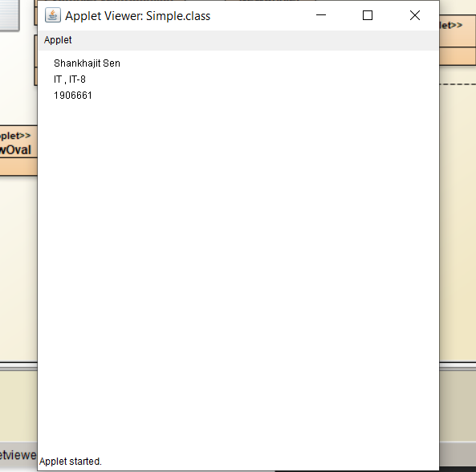

**Q2**

import java.applet.Applet;

import java.awt.*;

public class SmileyExc extends Applet {

public void paint(Graphics g) {

g.setColor(Color.cyan);

g.fillOval(20,20,150,150); // For face

g.setColor(Color.black);

g.fillOval(50,60,15,25); // Left Eye

g.fillOval(120,60,15,25); // Right Eye

int x[] = {95,85,106,95};

int y[] = {85,104,104,85};

g.drawPolygon(x, y, 4); // Nose

g.drawArc(55,95,78,50,0,-180); // Smile

g.drawLine(50,126,60,116); // Smile arc1

g.drawLine(128,115,139,126); // Smile arc2

}

}

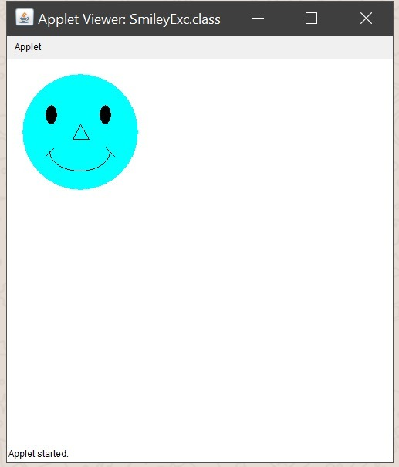

**Q3.**

// The Component Applet that displays several components

import java.applet.Applet;

import java.awt.*;

public class ComponentApplet extends Applet

{

public void init()

{

Button b = new Button("Test Button");

this.add(b);

Checkbox cb = new Checkbox("Test Checkbox");

this.add(cb);

CheckboxGroup cbg = new CheckboxGroup();

this.add(new Checkbox("CB Item 1", cbg, false));

this.add(new Checkbox("CB Item 2", cbg, false));

this.add(new Checkbox("CB Item 3", cbg, true));

Choice choice = new Choice();

choice.addItem("Choice Item 1");

choice.addItem("Choice Item 2");

choice.addItem("Choice Item 3");

this.add(choice);

Label l = new Label("Test Label");

this.add(l);

TextField t = new TextField("Tes t TextField",30);

this.add(t);

}

}

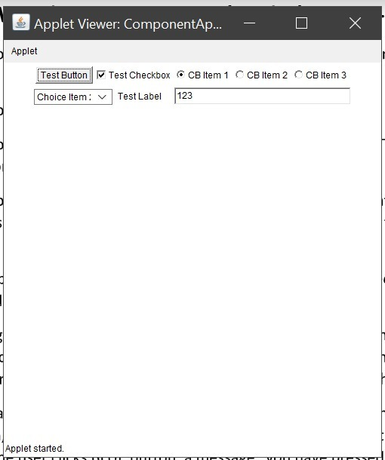

**Q4.**

import java.applet.Applet;

import java.awt.Color;

import java.awt.Graphics;

import java.awt.*;

import java.awt.event.*;

public class NewApplet extends Applet implements ActionListener {

Label l1,l2;

TextField t1;

Button btn;

public void init() {

// TODO start asynchronous download of heavy resources

l1=new Label("Enter Number");

l2=new Label("Result");

t1=new TextField();

btn=new Button("Check");

add(l1);

add(t1);

add(btn);

add(l2);

btn.addActionListener(this);

}

public void actionPerformed(ActionEvent e){

if(e.getSource() == btn){

if(Integer.parseInt(t1.getText())%2==0){

l2.setText(t1.getText()+" is even");

}

else

{

l2.setText(t1.getText()+" is Odd");

}

}

}

}

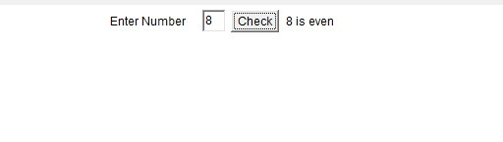

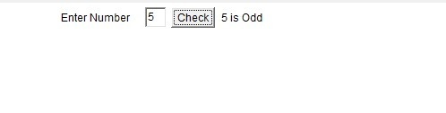

**Q5.**

import java.applet.Applet;

import java.awt.Color;

import java.awt.Graphics;

public class Five extends Applet{

public void init()

{

setSize(400, 400);

repaint();

}

public void paint(Graphics g)

{

g.setColor(Color.red);

g.fillRect(90, 90, 220, 220);

try{

Thread.sleep(300);

}catch (Exception e){

try {

throw e;

} catch (InterruptedException interruptedException) {

interruptedException.printStackTrace();

}

}

g.setColor(Color.blue);

g.fillRect(100, 100, 200, 200);

try{

Thread.sleep(600);

}catch (Exception e){

try {

throw e;

} catch (InterruptedException interruptedException) {

interruptedException.printStackTrace();

}

}

g.setColor(Color.yellow);

g.fillRect(110, 110, 180, 180);

try{

Thread.sleep(900);

}catch (Exception e){

try {

throw e;

} catch (InterruptedException interruptedException) {

interruptedException.printStackTrace();

}

}

g.setColor(Color.green);

g.fillRect(120, 120, 160, 160);

try{

Thread.sleep(1200);

}catch (Exception e){

try {

throw e;

} catch (InterruptedException interruptedException) {

interruptedException.printStackTrace();

}

}

g.setColor(Color.pink);

g.fillRect(130, 130, 140, 140);

}

}

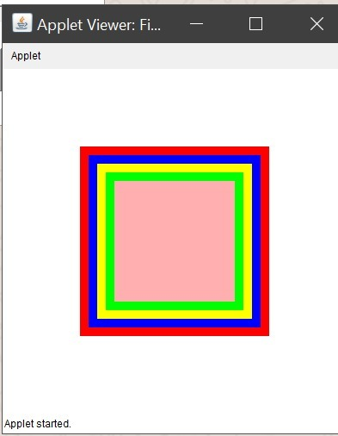

**Q6.**

import java.awt.*;

import java.awt.event.*;

public class TextFieldExample extends Frame implements ActionListener{

TextField tf1,tf2,tf3;

Button b1,b2;

TextFieldExample(){

tf1=new TextField();

tf1.setBounds(50,50,150,20);

tf2=new TextField();

tf2.setBounds(50,100,150,20);

tf3=new TextField();

tf3.setBounds(50,150,150,20);

tf3.setEditable(false);

b1=new Button("+");

b1.setBounds(50,200,50,50);

b2=new Button("-");

b2.setBounds(120,200,50,50);

b1.addActionListener(this);

b2.addActionListener(this);

add(tf1);add(tf2);add(tf3);add(b1);add(b2);

setSize(300,300);

setLayout(null);

setVisible(true);

}

public void actionPerformed(ActionEvent e) {

String s1=tf1.getText();

String s2=tf2.getText();

int a=Integer.parseInt(s1);

int b=Integer.parseInt(s2);

int c=0;

if(e.getSource()==b1){

c=a+b;

}else if(e.getSource()==b2){

c=a-b;

}

String result=String.valueOf(c);

tf3.setText(result);

}

public static void main(String[] args) {

new TextFieldExample();

}

}

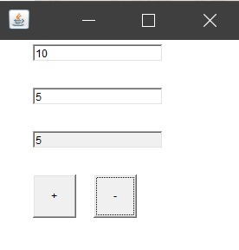

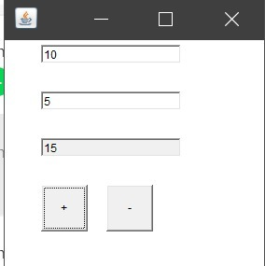

**Q7.**

import java.awt.*;

import java.awt.event.*;//necessary for buttons

import java.applet.*;

public class TwoButtons extends Applet implements ActionListener

{

//Declare a new string, and make a new "empty" mailbox

String sMessage = new String("");

//Declare two new buttons

Button Button1;

Button Button2;

public void init()

{

setBackground(Color.white);

//Turn Layout manager off

setLayout(null);

//Initialize the buttons and give them names

Button1 = new Button("First");

Button2 = new Button("Second");

//add the buttons to the applet

add(Button1);

add(Button2);

//Position Buttons(X, Y, Width, Height);

Button1.setBounds(10,20,50,20);

Button2.setBounds(10,60,50,20);

//Change color of Buttons

Button1.setBackground(Color.red);

Button2.setBackground(Color.blue);

//Change color of text on Buttons

Button1.setForeground(Color.blue);

Button2.setForeground(Color.white);

//Make a new method that "listens" for the button press

Button1.addActionListener(this);

Button2.addActionListener(this);

}

public void actionPerformed(ActionEvent ae)

{

//store the name of the button pressed in sString

String sString = ae.getActionCommand();

if (sString.equals("First"))

sMessage = "you have passed RED";

else if (sString.equals("Second"))

sMessage = "you have pressed BLUE";

repaint();

}

public void paint (Graphics g)

{

g.drawString(sMessage,10,100);

}

}

